6



I

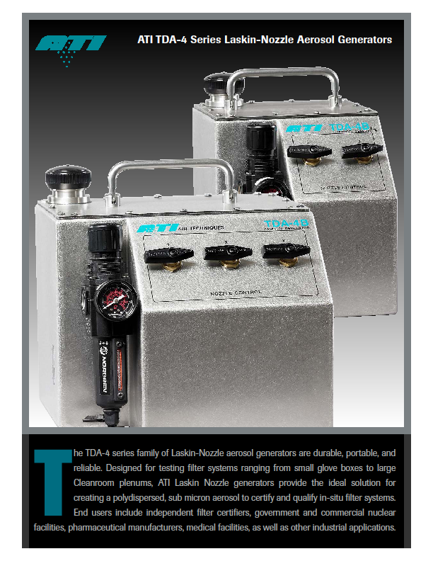

**TDA -4B气溶胶发生器**

**TDA-4B Laskin-Nozzle aerosol generators**

**TDA -4B气溶胶发生器产品介绍：**   
       our ISO-9001 registered, NQA-1 &

**TDA-4B Laskin-Nozzle aerosol generators product introduction**

TDA-4B是一个的耐用，轻重量便携式可靠的拉丝金喷嘴气溶胶发生器。ATI拉丝金喷嘴气溶胶发生器设计用于测试小的手套箱至大洁净区域，它是理想的能产生次微米的多种直径的气溶胶粒子测试验证过滤单元系统。

OE audited Test Laboratory

**A Tough, Portable Solution**

The TDA-4B series family of Laskin-Nozzle aerosol generators are durable, portable, and reliable. Designed for testing filter systems ranging from small glove boxes to large Cleanroom plenums, ATI Laskin Nozzle generators provide the ideal solution for creating a polydispersed, sub micron aerosol

to certify and qualify in-situ filter systems.

**一个灵活的解决方案**

TDA-4B是气溶胶发生器根据工业标准生产和可调节的浓度输出满足应用要求，气溶胶浓度输出根据气溶胶发生器型号，气溶胶发生器和气溶胶光度计结合使用检测单个过滤器或高效过滤系统的泄漏，可达到浓度从 10 到100 微克/升，当流速在 405 到 8,100 立方英尺每分钟之间。

**A Flexible Solution**

The TDA-4B family of aerosol generators produce an industry standard true Laskin

III-A repeatable aerosol and feature adjustable aerosol concentration output to

meet multiple application requirements. These generators are used in conjunction

with an aerosol photometer to measure the aerosol penetration of an individual filter or

filter system, typically to identify, quantify and repair leaks. Aerosol concentration output

varies by generator model; however concentrations can be achieved from

100 ug/l down to 10 ug/l at airflows ranging from 405 to 8,100 cfm*.

**坚固简易化设计**

  TDA-4B 坚固的不锈钢结构并且带有容用卫生的构造，大的填装口，独立的喷头和压力控制及 3英寸标准的接头输出。

**Rugged Convenient Design**

The TDA-4B family features rugged stainless steel, with easily cleanable construction, a

large fill port, jet and pressure control, and a standard three-inch sanitary fitting outlet collar.

**TDA-4B气溶胶发生器技术参数:**

**TDA-4B Laskin-Nozzle aerosol generators product pecification.**

尺寸：11” L × 11” W × 10” H (长X宽X高)；

**SIZE:** 11" (L) x 11" (W) x 10" (H) 11" (L) x 8" (W) x 10" (H)

重量：7.3KG；

**WEIGHT:** 16lbs (7.3kg)

系统风量要求：50-8,100立方英尺每分钟；

**AEROSOL OUTPUT:** 50 – 8,100 cfm

悬浮粒子浓度：流量为8100立方英尺每分钟时浓度为10微克/升，流量为810立方英尺每分钟时浓度为100微克/升；

**CONCENTRATION:** 100 ug/l @*: 810 cfm， 10 ug/l @*: 8,100 cfm

产生类型：1-6个拉丝金喷嘴喷射；

**GENERATOR TYPE:** 1 to 6 Laskin Nozzle

压缩空气：20 psig

**COMPRESSED AIR:** min 2.65 cfm/nozzle @ 20 psig

气体类型：多分散相（冷发生）

**AEROSOL TYPE:** Poly-dispersed (Cold)